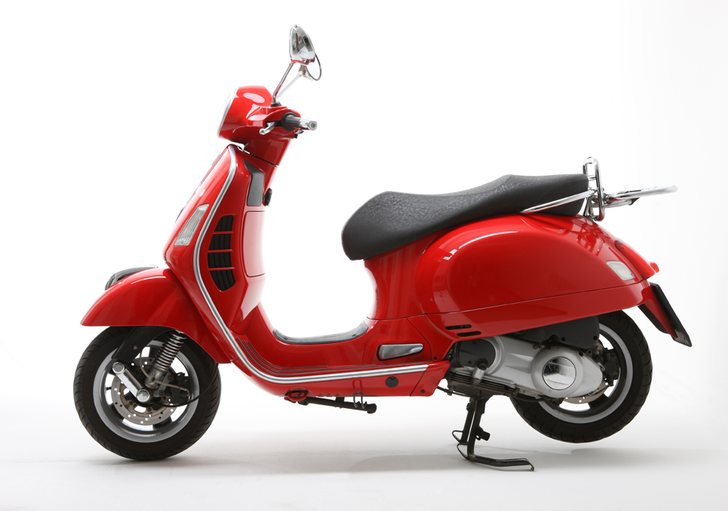

Win This Beautiful Handmade Quilt

“Sugar & Spice” 88 x 96

Drawing will be held on Dec 6, 2018 at The Artisans Village Art Gallery.

Original Design by Mary Kay Mouton, Long arm quilting by Carol Mcrae, donated by Jane Harding

**Raffle Tickets**

**$10 each**

**6 for $50**

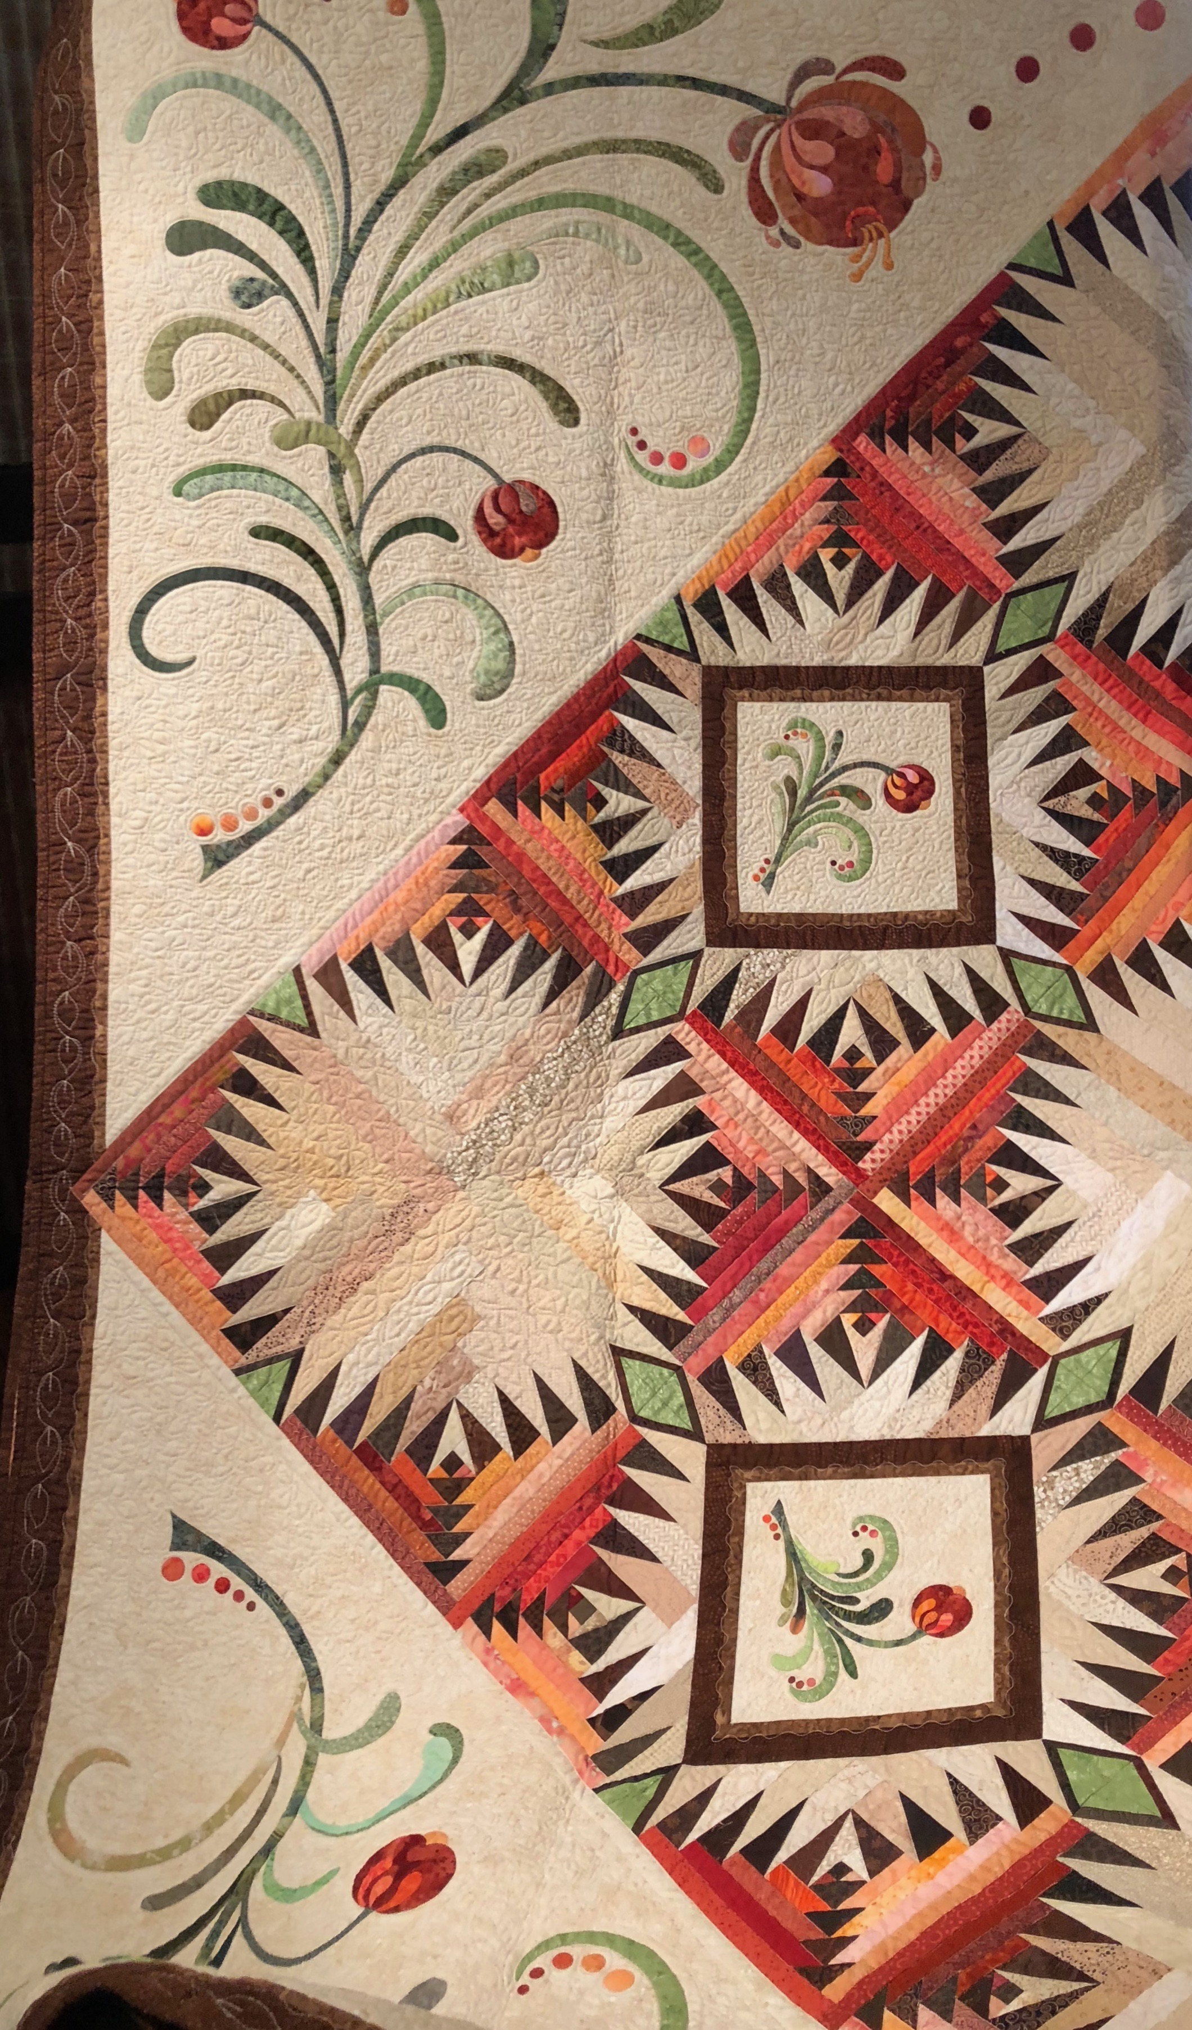

**All Proceeds will benefit The Artisans Village**